|  |
| --- |
| NIM : 672019061  NAMA : Afiyatar Asyer |

**S1 TEKNIK INFORMATIKA**

**FAKULTAS TEKNOLOGI INFORMASI**

# UNIVERSITAS KRISTEN SATYA WACANA

**UJIAN TENGAH SEMESTER** Nama Matakuliah : Teknik Optimalisasi

Waktu : Take Home Test

Dosen : Hendry, PhD

Sifat : Open Book

**PETUNJUK PENGERJAAN :**

* Berdoalah sebelum Anda mulai mengerjakan.
* Kerjakanlah soal berikut ini dengan cermat dan teliti !

Selesaikan permasalahan kontinu berikut menggunakan metode algoritma genetik dan differential evolution. Mahasiswa bisa mengembangkan dari metode dasar yang sudah dipelajari dalam materi mata kuliah.

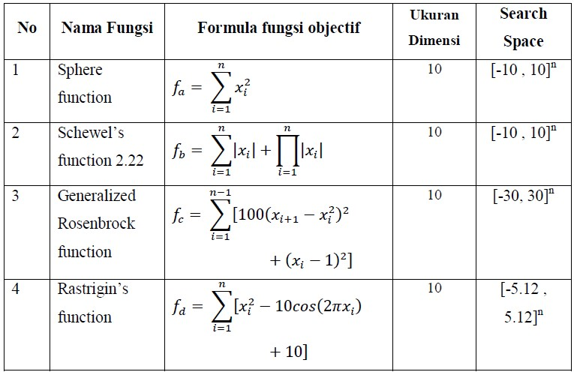

Lakukan eksperimen dengan kriteria

* 1. jumlah maksimum evaluasi fungsi objective adalah 1.000.

Contoh :

* + 1. misal populasinya 10, dan setiap iterasi menghasilkan 10 solusi baru, maka jumlah maksimum iterasi untuk kasus tersebut adalah max_it = (1000-P)/10 = (1000-10)/10 = 99
    2. misal populasinya 10, dan setiap iterasi menghasilkan 2 solusi baru, maka jumlah maksimum iterasi untuk kasus tersebut adalah max_it = (1000-P)/2 = (1000-10)/2 = 495
  1. Setiap fungsi di run 30 kali, kemudian tentukan nilai terbaik, nilai rata-rata dan standar deviasinya

Hasil eksperimen kemudian dituliskan dalam bentuk laporan yang berisi:

* 1. Penjelasan metode metaheuristik yang dipakai untuk menyelesaikan permasalahan diatas. (representasi penyelesaian, tuning parameter, dll)
  2. Hasil Experimen dan Analisisnya

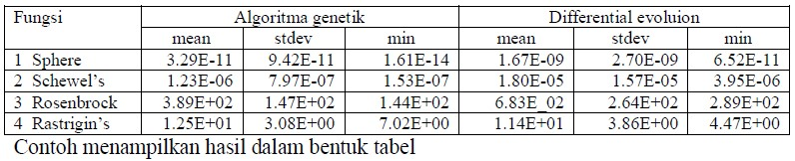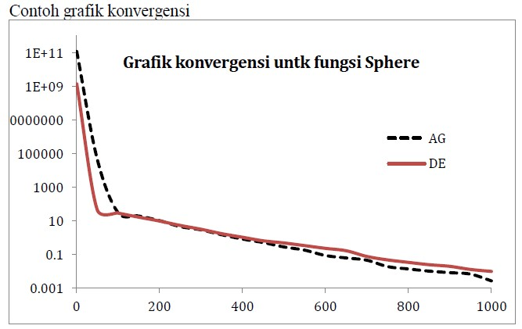

**TES TENGAH SEMESTER**

**TEKNIK OPTIMASI**

Pemecahan masalah:

1. Algoritma Genetika
2. Sphere Function
3. Poin A

Dari hasil percobaan codingan menggunakan Algoritma Genetika dengan max_it = (1000-P)/10 = (1000-10)/10 = 99 serta nilai yang diketahui:

|  |
| --- |
| i = 1 |
| epochs = 99 |
| minFit = -10 |
| maxFit = 10 |

Menghasilkan Populasi:

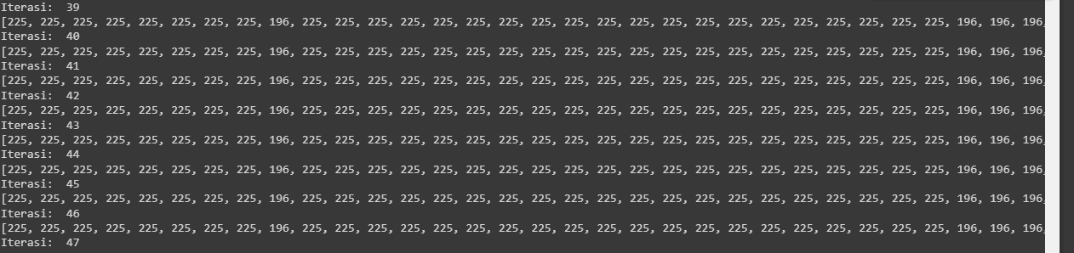

Serta fungsi di run sebanyak 30 kali menghasilkan:

**Nilai Mean** : 204.2020202020202

**Nilai Standard Deviation** : 13.127304305382667

**Nilai Minimal** : 196

Hasil Grafik:

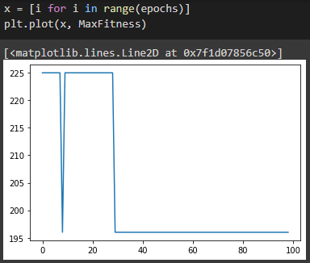

1. Poin B

Dari hasil percobaan codingan menggunakan Algoritma Genetika dengan max_it = (1000-P)/2 = (1000-10)/2 = 495 serta nilai yang diketahui:

|  |
| --- |
| i = 1 |
| epochs = 495 |
| minFit = -10 |
| maxFit = 10 |

Menghasilkan Populasi:

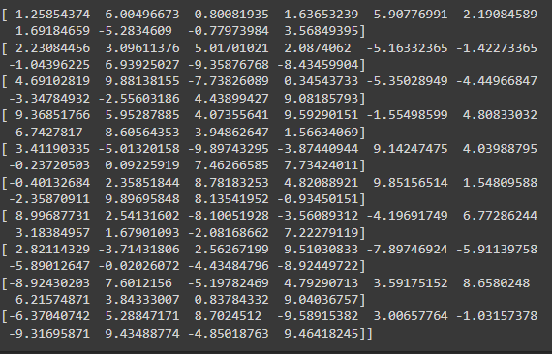

Serta fungsi di run sebanyak 30 kali menghasilkan:

**Nilai Mean** : 0.39595959595959596

**Nilai Standard Deviation** : 8.809544869519696

**Nilai Minimal** : 0

Hasil Grafik:

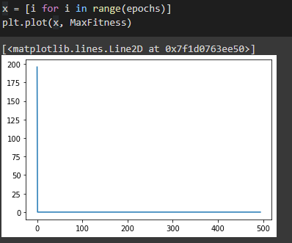

1. Schewel’s Function 2.22
2. Poin A

Dari hasil percobaan codingan menggunakan Algoritma Genetika dengan max_it = (1000-P)/10 = (1000-10)/10 = 99 serta nilai yang diketahui:

|  |
| --- |
| i = 1 |
| epochs = 99 |
| minFit = -10 |
| maxFit = 10 |

Menghasilkan Populasi:

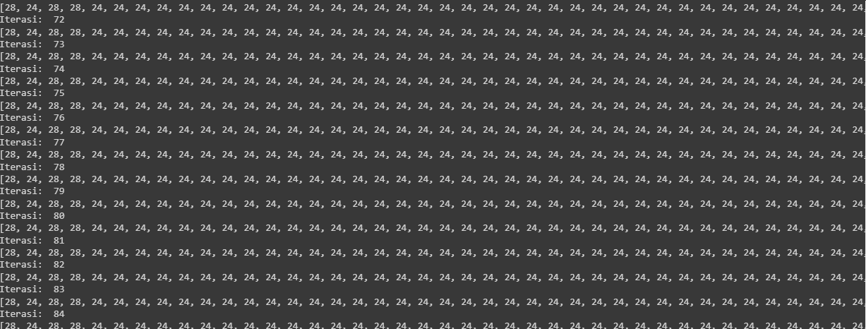

Serta fungsi di run sebanyak 30 kali menghasilkan:

**Nilai Mean** : 24

**Nilai Standard Deviation** : 0

**Nilai Minimal** : 24

Hasil Grafik:

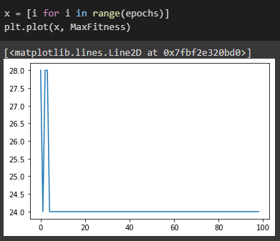

1. Poin B

Dari hasil percobaan codingan menggunakan Algoritma Genetika dengan max_it = (1000-P)/2 = (1000-10)/2 = 495 serta nilai yang diketahui:

|  |
| --- |
| i = 1 |
| epochs = 495 |
| minFit = -10 |
| maxFit = 10 |

Menghasilkan Populasi:

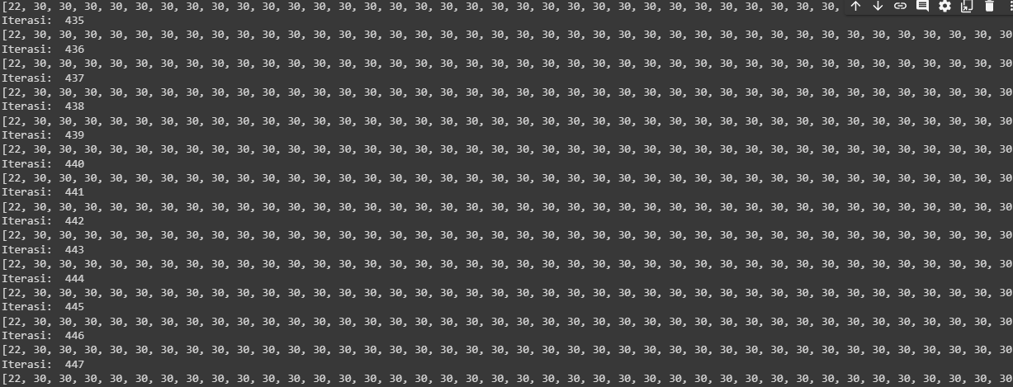

Serta fungsi di run sebanyak 30 kali menghasilkan:

**Nilai Mean** : 29

**Nilai Standard Deviation** : 0

**Nilai Minimal** : 22

Hasil Grafik:



1. Generalize rosenbrock Function
2. Poin A

Dari hasil percobaan codingan menggunakan Algoritma Genetika dengan max_it = (1000-P)/10 = (1000-10)/10 = 99 serta nilai yang diketahui:

|  |
| --- |
| i = 1 |
| epochs = 99 |
| minFit = -30 |
| maxFit = 3x0 |

Menghasilkan Populasi:

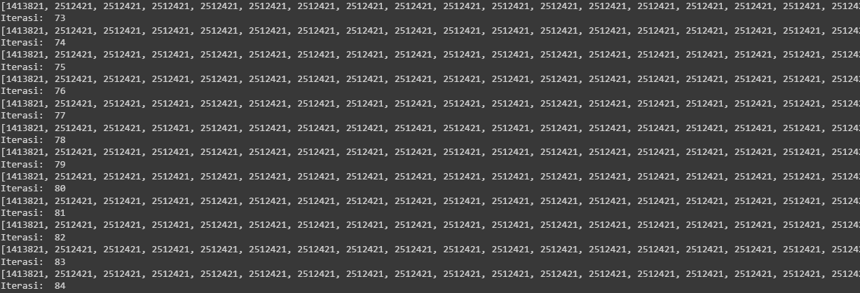

Serta fungsi di run sebanyak 30 kali menghasilkan:

**Nilai Mean** : 2501324

**Nilai Standard Deviation** : 110413.45438396536

**Nilai Minimal** : 1413821

Hasil Grafik:

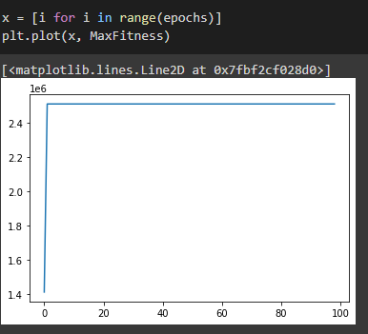

1. Poin B

Dari hasil percobaan codingan menggunakan Algoritma Genetika dengan max_it = (1000-P)/2 = (1000-10)/2 = 495 serta nilai yang diketahui:

|  |
| --- |
| i = 1 |
| epochs = 495 |
| minFit = -30 |
| maxFit = 30 |

Menghasilkan Populasi:

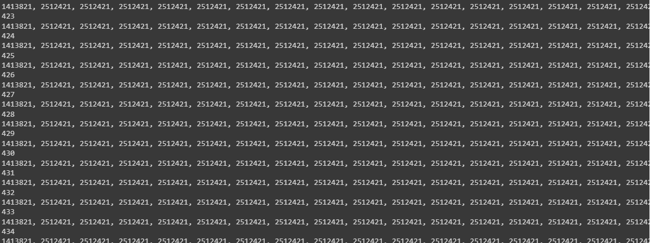

Serta fungsi di run sebanyak 30 kali menghasilkan:

**Nilai Mean** : 2509012

**Nilai Standard Deviation** : 55969.79841843277

**Nilai Minimal** : 1413821

Hasil Grafik:

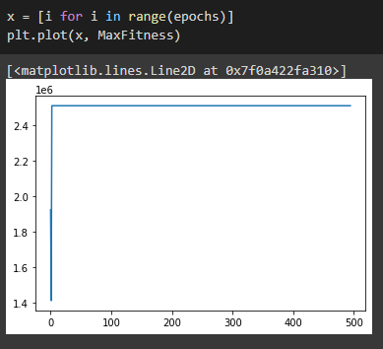

1. Rastrigin’s Function
2. Poin A

Dari hasil percobaan codingan menggunakan Algoritma Genetika dengan max_it = (1000-P)/10 = (1000-10)/10 = 99 serta nilai yang diketahui:

|  |
| --- |
| i = 1 |
| epochs = 99 |
| minFit = -5.12 |
| maxFit = 5.12 |

Menghasilkan Populasi:

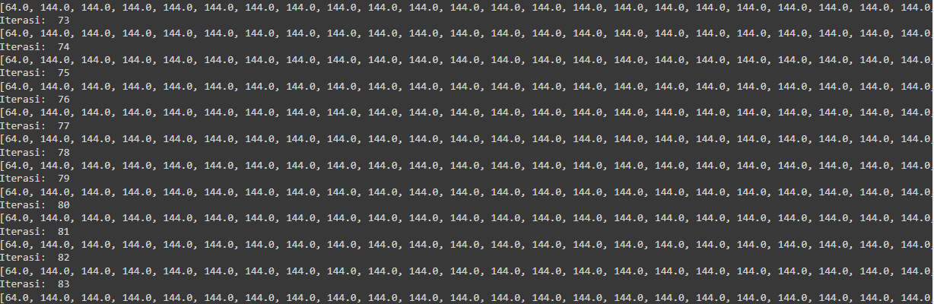

Serta fungsi di run sebanyak 30 kali menghasilkan:

**Nilai Mean** : 143.1919191919192

**Nilai Standard Deviation** : 8.040302522073697

**Nilai Minimal** : 64.0

Hasil Grafik:



1. Poin B

Dari hasil percobaan codingan menggunakan Algoritma Genetika dengan max_it = (1000-P)/2 = (1000-10)/2 = 495 serta nilai yang diketahui:

|  |
| --- |
| i = 1 |
| epochs = 495 |
| minFit = -5.12 |
| maxFit = 5.12 |

Menghasilkan Populasi:

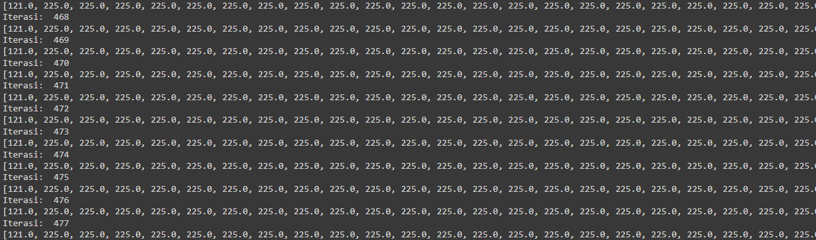

Serta fungsi di run sebanyak 30 kali menghasilkan:

**Nilai Mean** : 224.789898989899

**Nilai Standard Deviation** : 4.674452379745145

**Nilai Minimal** : 121.0

Hasil Grafik:

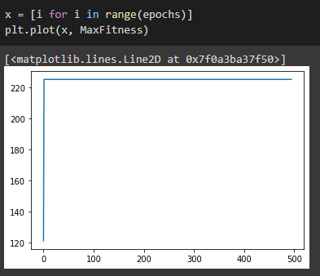

1. Differential Evolution
   1. Sphere Function
2. Poin A

Dari hasil percobaan codingan menggunakan Defferential Evolution dengan max_it = (1000-P)/10 = (1000-10)/10 = 99 serta nilai yang diketahui:

|  |
| --- |
| D = 10 # Dimensi dari permasalahan |
| maxit = 99 #Max iterasi |
| ukuranPopulasi = 10 |
| LB = -10 #Batas Bawah |
| UB = 10 #Batas Atas |
| CR = 0.9 |
| F = 0.5 |

Menghasilkan Populasi:

|  |
| --- |
| [ 5.69622364 -9.77272772 -8.23100607 -6.47651935 -7.01127811 2.86234108 |
| 9.15963831 -8.82896704 -6.82454823 -8.44254531] |
| [-8.50629736 6.44187377 2.43136056 -5.28877532 1.70407556 6.15200632 |
| -0.80228779 -1.23550781 -1.64848515 -0.67735818] |
| [ 3.96002675 -2.56211483 -1.17381326 4.28349931 -1.97867226 2.51688329 |
| 7.15746641 -4.11080985 2.21996604 -7.81933746] |
| [ 2.66710187 4.31371608 -3.87726489 5.30822543 8.99155279 -2.91639314 |
| 7.78476023 4.32537916 0.38064641 4.77324052] |
| [ 4.96449287 -3.61168306 9.56688097 3.48700723 5.9448273 2.48740972 |
| 9.05995896 -1.06552936 6.83874003 8.77041278] |
| [-4.85051854 -7.43523641 -6.37721882 -8.45204101 9.24913917 -0.03213903 |
| -5.86917081 -9.92411394 -6.26045077 9.69013618] |
| [-0.34018508 8.72744673 -4.44127703 -8.22533886 -2.42806967 8.74088018 |
| -3.05250204 -7.61924065 5.51878122 1.66888765] |
| [ 0.78397727 -5.63639414 -4.88399924 -3.32307591 -4.88506801 2.59119844 |
| 5.51257767 -1.91504583 -1.91480962 6.93258055] |
| [-9.02182498 8.99499721 -5.34738778 4.37025215 -4.30535137 5.39403455 |
| 2.56665363 7.14115949 -4.09935427 -4.58248127] |
| [-1.9732305 7.363828 6.77122162 -6.75696552 -6.86499639 -2.38402261 |
| -5.90980649 0.24289997 -6.75298643 5.1915824 ] |

Serta fungsi di run sebanyak 30 kali menghasilkan:

**Nilai Mean** : 39.045273875157235

**Nilai Standard Deviation** : 65.73583350532162

**Nilai Minimal** : 0.00294986216248811

Hasil Grafik:

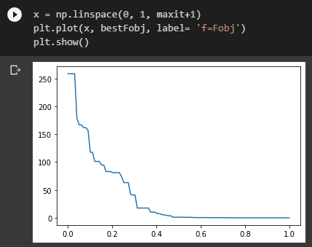

1. Poin B

Dari hasil percobaan codingan menggunakan Algoritma Genetika dengan max_it = (1000-P)/2 = (1000-10)/2 = 495 serta nilai yang diketahui:

|  |
| --- |
| D = 10 # Dimensi dari permasalahan |
| maxit = 495 #Max iterasi |
| ukuranPopulasi = 10 |
| LB = -10 #Batas Bawah |
| UB = 10 #Batas Atas |
| CR = 0.9 |
| F = 0.5 |

Menghasilkan Populasi:

|  |
| --- |
| [ 1.25854374 6.00496673 -0.80081935 -1.63653239 -5.90776991 2.19084589 |
| 1.69184659 -5.2834609 -0.77973984 3.56849395] |
| [ 2.23084456 3.09611376 5.01701021 2.0874062 -5.16332365 -1.42273365 |
| -1.04396225 6.93925027 -9.35876768 -8.43459904] |
| [ 4.69102819 9.88138155 -7.73826089 0.34543733 -5.35028949 -4.44966847 |
| -3.34784932 -2.55603186 4.43899427 9.08185793] |
| [ 9.36851766 5.95287885 4.07355641 9.59290151 -1.55498599 4.80833032 |
| -6.7427817 8.60564353 3.94862647 -1.56634069] |
| [ 3.41190335 -5.01320158 -9.89743295 -3.87440944 9.14247475 4.03988795 |
| -0.23720503 0.09225919 7.46266585 7.73424011] |
| [-0.40132684 2.35851844 8.78183253 4.82088921 9.85156514 1.54809588 |
| -2.35870911 9.89695848 8.13541952 -0.93450151] |
| [ 8.99687731 2.54131602 -8.10051928 -3.56089312 -4.19691749 6.77286244 |
| 3.18384957 1.67901093 -2.08168662 7.22279119] |
| [ 2.82114329 -3.71431806 2.56267199 9.51030833 -7.89746924 -5.91139758 |
| -5.89012647 -0.02026072 -4.43484796 -8.92449722] |
| [-8.92430203 7.6012156 -5.19782469 4.79290713 3.59175152 8.6580248 |
| 6.21574871 3.84333007 0.83784332 9.04036757] |
| [-6.37040742 5.28847171 8.7024512 -9.58915382 3.00657764 -1.03157378 |
| -9.31695871 9.43488774 -4.85018763 9.46418245] |

Serta fungsi di run sebanyak 30 kali menghasilkan:

**Nilai Mean** : 6.253351485484217

**Nilai Standard Deviation** : 28.59080188472914

**Nilai Minimal** : 0.3915633902944092

Hasil Grafik:

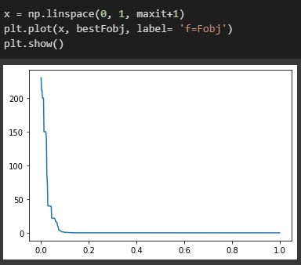

* 1. Schewel’s Function 2.22

1. Poin A

Dari hasil percobaan codingan menggunakan Defferential Evolution dengan max_it = (1000-P)/10 = (1000-10)/10 = 99 serta nilai yang diketahui:

|  |
| --- |
| D = 10 # Dimensi dari permasalahan |
| maxit = 99 #Max iterasi |
| ukuranPopulasi = 10 |
| LB = -10 #Batas Bawah |
| UB = 10 #Batas Atas |
| CR = 0.9 |
| F = 0.5 |

Menghasilkan Populasi:

|  |
| --- |
| [-7.60150902 2.39583676 3.2683578 -3.14154693 -4.28265303 -1.5768425 |
| 4.82188716 -3.60759683 -8.80893321 -1.59421434] |
| [ 2.61109487 -7.20880547 7.05810423 -1.40019624 9.41536103 9.18794912 |
| 2.04349291 8.84909036 -4.18218125 -6.46676852] |
| [-8.54349277 0.45874522 -1.36669332 0.97355784 -3.59369362 -1.63170636 |
| -0.20612024 2.02489683 9.32521902 5.61500509] |
| [ 9.33583352 2.53643434 -4.18710696 8.77198854 -8.11729087 -3.5368533 |
| 0.78400984 4.21304702 2.2370119 -6.72486315] |
| [-1.8115141 1.97487091 -8.69973273 -0.77904277 9.69633998 1.35760893 |
| -3.51025469 5.61318042 -2.65392451 -3.72278878] |
| [ 5.0170669 8.68295548 -8.83323428 -3.93366733 0.59113996 -4.40024356 |
| -7.49738274 -4.65143857 4.07595081 -2.68152885] |
| [ 9.06168264 -6.72211694 1.72863966 7.0072561 -0.6778801 -1.0370398 |
| 9.17727341 -9.16964738 -0.77560448 7.66325911] |
| [-9.46453123 4.6550682 4.93639552 7.47631702 -2.64677153 9.55215065 |
| -2.34689303 2.18793289 8.4342208 3.12784339] |
| [ 2.18139596 -4.4741004 4.12284846 -8.403091 6.32390902 -6.76765416 |
| -1.67651325 -9.08123829 7.51278439 -1.9393268 ] |
| [-2.96780188 -6.65101491 3.25417874 9.41692218 -5.76880906 9.49608055 |
| -7.36273648 0.61565673 5.79480816 7.56061276] |

Fungsi Objective :

[ 74.58637252 67.63652563 96.74014386 115.51225131 105.84099923 90.98413482 134.37920041 102.0135241 72.53778865 118.2703168 ]

Serta fungsi di run sebanyak 30 kali menghasilkan:

**Nilai Mean** : 12.37812068453818

**Nilai Standard Deviation** : 18.368908455434536

**Nilai Minimal** : 0.09755504747058841

Hasil Grafik:

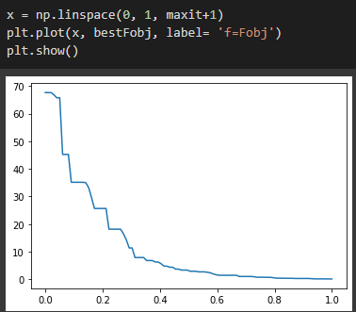

1. Poin B

Dari hasil percobaan codingan menggunakan Algoritma Genetika dengan max_it = (1000-P)/2 = (1000-10)/2 = 495 serta nilai yang diketahui:

|  |
| --- |
| D = 10 # Dimensi dari permasalahan |
| maxit = 495 #Max iterasi |
| ukuranPopulasi = 10 |
| LB = -10 #Batas Bawah |
| UB = 10 #Batas Atas |
| CR = 0.9 |
| F = 0.5 |

Menghasilkan Populasi:

|  |
| --- |
| [-4.04301875 0.53884136 8.00538886 -3.18897556 -7.86131553 -1.33503336 |
| -1.82652845 -2.3703909 -6.09920286 5.43886746] |
| [ 3.26844945 -2.57427516 -4.52919619 -4.28008403 0.0772137 -5.11631276 |
| -1.26177483 -3.16590835 1.52185851 -5.34046065] |
| [ 3.93840673 5.98670356 -5.01539932 1.44669619 -9.52649048 9.85866649 |
| 8.69204064 8.47641365 6.29342124 3.17994647] |
| [ 4.59670209 2.72171256 -4.17595002 6.65078724 0.04273397 -0.24894272 |
| -2.05950487 -2.38839401 -5.87268808 -6.56585697] |
| [ 3.16352711 -0.80191217 8.34511496 2.21464723 5.55000968 0.68912663 |
| 6.6629669 -2.61657411 6.27443675 -4.8049696 ] |
| [-8.81458304 -1.41652709 0.85303005 -5.8910459 -8.86689798 2.17723232 |
| -6.81872751 -5.33849818 8.44511107 -8.05558786] |
| [-3.38133462 4.02782274 2.52367092 -4.38898674 5.03965094 3.28683238 |
| -6.32539395 6.36993378 -3.74536687 -7.49984454] |
| [-3.11465176 -3.81676883 6.8295952 1.09234056 2.97402781 2.2807242 |
| 1.27052054 1.4797594 2.26163101 -2.16090941] |
| [ 2.17601568 7.8755492 9.59599919 0.12987194 4.05252536 -0.51013306 |
| 3.92332676 1.74298907 4.46762636 -0.60371282] |
| [ 8.50170775 -4.45343165 -2.78230591 3.12361584 4.53377593 8.03079509 |
| 9.04568654 3.90613225 -2.63956582 8.6829121 ] |

Fungsi Objektif:

[ 81.41512616 62.27106726 124.82836952 70.64654504 82.24657027 113.354482 93.17767495 54.56185742 70.15549886 111.39985777]

Serta fungsi di run sebanyak 30 kali menghasilkan:

**Nilai Mean** : 2.1820240155997133

**Nilai Standard Deviation** : 9.959848743443919

**Nilai Minimal** : 5.620433788795094e-15

Hasil Grafik:

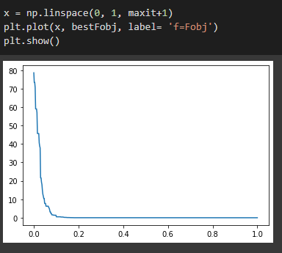

* 1. Generalize rosenbrock Function

1. Poin A

Dari hasil percobaan codingan menggunakan Defferential Evolution dengan max_it = (1000-P)/10 = (1000-10)/10 = 99 serta nilai yang diketahui:

|  |
| --- |
| D = 10 # Dimensi dari permasalahan |
| maxit = 99 #Max iterasi |
| ukuranPopulasi = 10 |
| LB = -30 #Batas Bawah |
| UB = 30 #Batas Atas |
| CR = 0.9 |
| F = 0.5 |

Menghasilkan Populasi:

|  |
| --- |
| [ -4.31989349 -6.02052172 -29.5944793 -16.05092933 17.32842641 |
| 27.09911361 19.61629467 15.80666967 -1.44566903 -15.57844307] |
| [-19.66339459 21.15936886 15.88259604 -15.84049668 -11.50072269 |
| -6.32702278 25.97403914 -7.66430191 20.79945561 5.19040482] |
| [ -4.4608596 -24.99790406 27.86278004 12.16987262 -22.31485918 |
| 9.62225434 20.0708507 -11.07587077 20.36860179 -9.18549819] |
| [-26.09522786 16.28695527 -1.27574002 16.70712843 -28.08497075 |
| -28.99156568 12.68388522 4.38982582 19.16753501 7.94150965] |
| [ 26.14859167 -11.94087323 27.51315127 3.42793625 -25.35915512 |
| 21.43179972 14.28349115 3.73670237 14.40532017 -19.34638537] |
| [ -2.05596653 -6.35502848 12.41003877 -23.75985261 22.009279 |
| -7.22870203 15.48147474 -13.0578926 -0.1819396 -6.7545737 ] |
| [ -6.6042105 3.03539158 -1.25727846 2.68786527 -10.90488097 |
| -25.6389763 6.11014714 16.92081144 -0.94923841 -8.1950749 ] |
| [ 19.13849986 -11.07323146 27.64585637 -7.27243905 19.2814311 |
| 6.80544275 25.74049504 22.41729553 -28.04585842 -26.84749239] |
| [-12.46969618 13.48106911 -24.08536713 19.27557991 -25.67674258 |
| -17.30789429 -20.2444812 13.84886958 -14.4622641 -20.69932867] |
| [ 26.1300471 -9.62219131 -17.85807845 -11.32324955 -11.91313974 |
| -3.69262528 18.52933747 -16.20897858 -23.83022307 -1.300887 ] |

Fungsi Objective :

[30645533.79752161 27147336.29914287 31672437.71651385 33938339.16500393 35455031.36859612 17121019.4301655 11661807.45655456 44141965.41514488 32530557.45484405 24119803.95882684]

Serta fungsi di run sebanyak 30 kali menghasilkan:

**Nilai Mean** : 2661784.5095996186

**Nilai Standard Deviation** : 4672830.927810584

**Nilai Minimal** : 1994.4194605694136

Hasil Grafik:

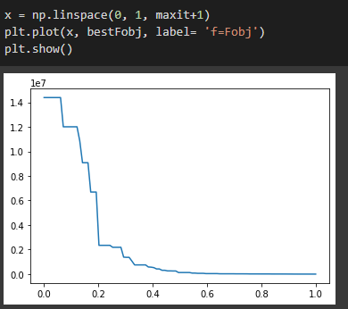

1. Poin B

Dari hasil percobaan codingan menggunakan Algoritma Genetika dengan max_it = (1000-P)/2 = (1000-10)/2 = 495 serta nilai yang diketahui:

|  |
| --- |
| D = 10 # Dimensi dari permasalahan |
| maxit = 495 #Max iterasi |
| ukuranPopulasi = 10 |
| LB = -30 #Batas Bawah |
| UB = 30 #Batas Atas |
| CR = 0.9 |
| F = 0.5 |

Menghasilkan Populasi:

|  |
| --- |
| [ -7.61081227 16.75428072 13.21043827 9.38809217 25.82375783 |
| -5.97266 16.72879063 13.07785531 9.79193829 6.31141543] |
| [ 14.11978806 20.20459763 26.02100856 18.28858776 22.17751602 |
| 8.0744026 -1.65119132 22.81829131 -10.81018187 7.66739252] |
| [-15.10608193 0.97648733 2.78299542 20.21540426 -22.63091213 |
| -0.22592397 -17.87334542 -8.32939924 7.02288728 -26.12762238] |
| [ -7.15930251 17.81181178 -26.86173356 20.98898672 14.43410529 |
| 17.60415444 14.01785515 1.76782069 20.82162597 -2.22402291] |
| [-25.67739085 29.91880602 18.05535191 5.13380508 -18.54210928 |
| -1.38544472 0.03642762 -19.30382664 23.95611823 -25.43411657] |
| [ 10.7763051 -8.35561497 6.11354222 -26.7781645 -14.38960392 |
| -23.84762208 -11.61579588 -8.19720304 -25.1864147 -6.95201705] |
| [ -4.62853907 27.95150174 14.55237837 23.55990911 3.19809128 |
| 29.5817369 -23.35268425 -19.60324441 15.03486828 28.29263551] |
| [ -8.1061652 -20.93191898 -2.15838804 -18.47794075 19.48967109 |
| 27.08795231 5.98748489 22.23064494 22.13023058 25.32642625] |
| [ -3.8058883 -9.50922113 -28.02666694 13.71607392 3.55230585 |
| 12.0658694 -23.06839754 6.16264274 26.01362888 27.60170642] |
| [-25.99298495 0.94112291 -3.11709472 -23.00655264 -21.68642299 |
| -6.54808417 -20.21544157 -29.37906683 -7.21067292 23.19687774] |

Fungsi Objektif:

[20560275.41139579 30795754.29945384 21260650.63404217 27847314.01302745 37536067.18847232 23447942.13629209 45209389.36433864 37066993.34578882 32400777.01344717 33057531.1409331 ]

Serta fungsi di run sebanyak 30 kali menghasilkan:

**Nilai Mean** : 382855.90483743796

**Nilai Standard Deviation** : 1976442.722855424

**Nilai Minimal** : 40.40093858396244

Hasil Grafik:

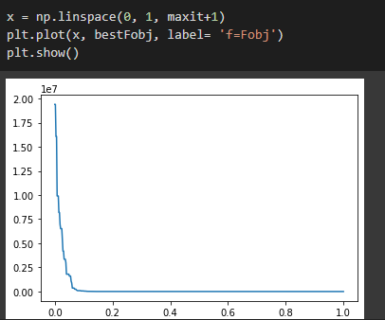

* 1. Rastrigin’s Function

1. Poin A

Dari hasil percobaan codingan menggunakan Defferential Evolution dengan max_it = (1000-P)/10 = (1000-10)/10 = 99 serta nilai yang diketahui:

|  |
| --- |
| D = 10 # Dimensi dari permasalahan |
| maxit = 99 #Max iterasi |
| ukuranPopulasi = 10 |
| LB = -5.12 #Batas Bawah |
| UB = 5.12 #Batas Atas |
| CR = 0.9 |
| F = 0.5 |

Menghasilkan Populasi:

|  |
| --- |
| [-2.15754919 -3.50031577 -2.70433695 -1.06363627 -0.42612007 4.00825165 |
| 2.13396615 0.3162541 -4.69803543 -0.92078303] |
| [ 3.43997084 1.40887612 0.50470684 -3.3083668 -1.21082204 -3.39203186 |
| 2.66504885 -1.51843372 0.18723296 1.22455745] |
| [ 3.51651352 0.57799963 0.69904877 -2.80522963 -3.2493769 -2.04398902 |
| 0.80243709 -0.18547343 -3.32317425 -2.48133956] |
| [ 2.89309994 4.09039297 -1.39674521 -5.08050672 -1.3607342 -3.75167291 |
| -3.43667007 -4.37002884 -5.10198188 -0.58850435] |
| [ 0.65755065 -3.81896762 -2.87322127 2.57811342 1.42285133 -2.65074536 |
| -3.35207745 2.71946112 -1.5467619 -5.02033034] |
| [ 3.21162776 3.98093537 -0.27248704 3.81855068 4.69266979 4.7656973 |
| -3.53666827 0.11320444 1.35384729 -2.97585924] |
| [-0.37417792 0.33108811 -4.55107447 -2.41535253 2.43892343 -1.64717123 |
| 5.01907706 -2.92151459 -1.46160153 -4.9858677 ] |
| [ 3.1969741 4.64249687 -1.72233152 0.34318446 -4.63895299 3.23263126 |
| 1.86182636 -1.23399887 4.95800155 -0.6537128 ] |
| [ 3.75374981 2.20813773 1.51968391 -3.95211108 2.44692879 -2.78184265 |
| -2.63105429 -1.20877899 -2.20183148 -2.3766895 ] |
| [ 4.86347726 3.8190673 2.95832359 -2.7419668 -1.63198534 -0.55755049 |
| -0.20698455 -2.79328086 -1.6632247 1.61285433] |

Fungsi Objective :

[158.061709 195.15231719 169.71779216 231.88462337 210.5453206 194.56450994 222.5051991 200.96710363 182.90166477 174.3225815 ]

Serta fungsi di run sebanyak 30 kali menghasilkan:

**Nilai Mean** : 76.98217421933484

**Nilai Standard Deviation** : 18.245435904923628

**Nilai Minimal** : 64.5119213263452

Hasil Grafik:

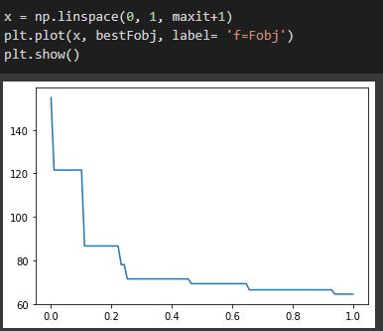

1. Poin B

Dari hasil percobaan codingan menggunakan Algoritma Genetika dengan max_it = (1000-P)/2 = (1000-10)/2 = 495 serta nilai yang diketahui:

|  |
| --- |
| D = 10 # Dimensi dari permasalahan |
| maxit = 495 #Max iterasi |
| ukuranPopulasi = 10 |
| LB = -5.12 #Batas Bawah |
| UB = 5.12 #Batas Atas |
| CR = 0.9 |
| F = 0.5 |

Menghasilkan Populasi:

|  |
| --- |
| [-3.2624089 -1.49039916 -3.23395392 -3.45809705 2.79498964 -2.55798858 |
| 2.43109578 -3.84155635 3.38225337 -3.1593795 ] |
| [-4.96577034 3.67998815 -3.00965051 -4.14117572 3.37125551 -4.72333636 |
| 2.25790292 -2.40802317 -2.55694828 -4.96389869] |
| [-3.74524393 -3.03583626 -2.59040671 -2.92361815 -1.90616482 -1.56325007 |
| 1.65395186 -0.11823577 0.73703835 -1.4717998 ] |
| [ 4.450193 3.39059319 4.85541336 1.35805933 -4.79226438 -0.23229507 |
| -3.00187602 -4.69191832 -4.59975205 -1.38296498] |
| [-2.38084244 3.92483052 4.12030404 0.15784405 -3.2262759 3.35222084 |
| -0.22299671 4.98344965 4.77082471 -1.21258905] |
| [-1.13971517 -1.14247076 -3.89817727 -1.92857946 0.48916429 -0.79525553 |
| -4.18576982 1.35591617 2.48063094 3.50613934] |
| [ 3.73048957 -1.57626963 3.5442358 4.3315732 0.58517554 -0.23831071 |
| -2.79218961 -0.90566567 2.36991679 -0.2613543 ] |
| [-3.46049838 -4.78393875 4.95038207 -2.13505006 0.01010492 -4.59807786 |
| 3.39433049 0.18658997 -3.07106186 2.2230482 ] |
| [ 3.66678713 1.12027553 3.01558764 -2.21370538 3.72516772 3.74591907 |
| -0.44044049 -1.8811086 -1.88492058 -1.534121 ] |
| [ 0.8941392 -1.71348102 4.10344458 -3.38960115 2.45283715 -3.46624229 |
| -3.87680107 2.09612014 -0.1872964 0.23995961] |

Fungsi Objektif:

[223.32125038 235.41434 150.02347486 256.55879554 183.74504968 159.86023523 191.55072537 193.91827206 157.79950107 163.23389168]

Serta fungsi di run sebanyak 30 kali menghasilkan:

**Nilai Mean** : 39.66523750432544

**Nilai Standard Deviation** : 25.229802589630165

**Nilai Minimal** : 19.470490042715884

Hasil Grafik:

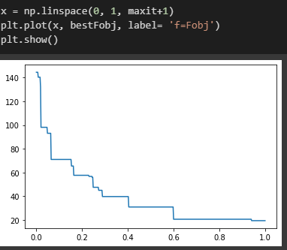

Summary Tabel

Poin 1 dengan percobaan iterasi 99

|  |  |  |  |  |  |  |
| --- | --- | --- | --- | --- | --- | --- |
| **Fungsi** | **Algoritma Genetik** | | | **Differential Evolution** | | |
| Mean | Stdev | Min | Mean | Stdev | Min |
| **Sphere** | 204.2020202020202 | 13.127304305382667 | 196 | 39.045273875157235 | 65.73583350532162 | 0.00294986216248811 |
| **Schewel’s 2.22** | 24 | 0 | 24 | 12.37812068453818 | 18.368908455434536 | 0.09755504747058841 |
| **Generalize rosenbrock** | 2501324 | 110413.45438396536 | 1413821 | 2661784.5095996186 | 4672830.927810584 | 1994.4194605694136 |
| **Rastrigin’s** | 143.1919191919192 | 8.040302522073697 | 64.0 | 76.98217421933484 | 18.245435904923628 | 64.5119213263452 |

Poin 2 dengan percobaan iterasi 495

|  |  |  |  |  |  |  |
| --- | --- | --- | --- | --- | --- | --- |
| **Fungsi** | **Algoritma Genetik** | | | **Differential Evolution** | | |
| Mean | Stdev | Min | Mean | Stdev | Min |
| **Sphere** | 0.39595959595959596 | 8.809544869519696 | 0 | 6.253351485484217 | 28.59080188472914 | 0.3915633902944092 |
| **Schewel’s 2.22** | 29 | 0 | 22 | 2.1820240155997133 | 9.959848743443919 | 5.620433788795094e-15 |
| **Generalize rosenbrock** | 2509012 | 55969.79841843277 | 1413821 | 382855.90483743796 | 1976442.722855424 | 40.40093858396244 |
| **Rastrigin’s** | 224.789898989899 | 4.674452379745145 | 121.0 | 39.66523750432544 | 25.229802589630165 | 19.470490042715884 |